**Steps to create a instance in GCP:**

1. Go to GCP console(<https://console.cloud.google.com>).

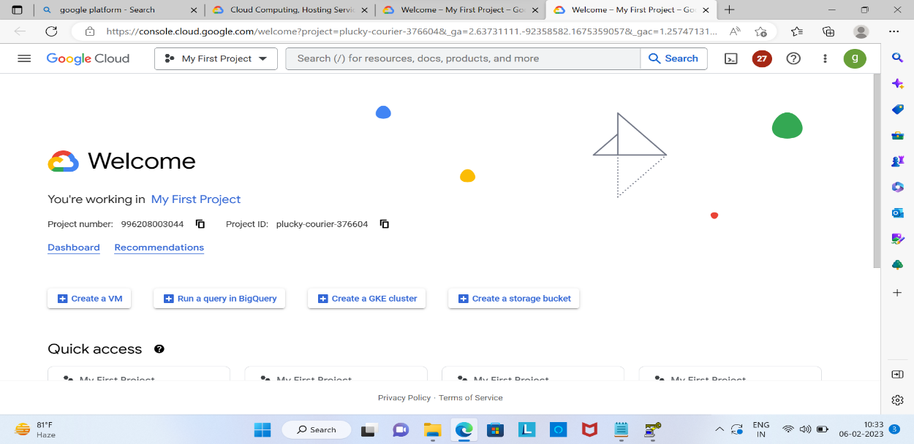

1. Click the hamburger menu and select **Compute Engine**, click on **VM instance** button. Then And click on **Create instance**.

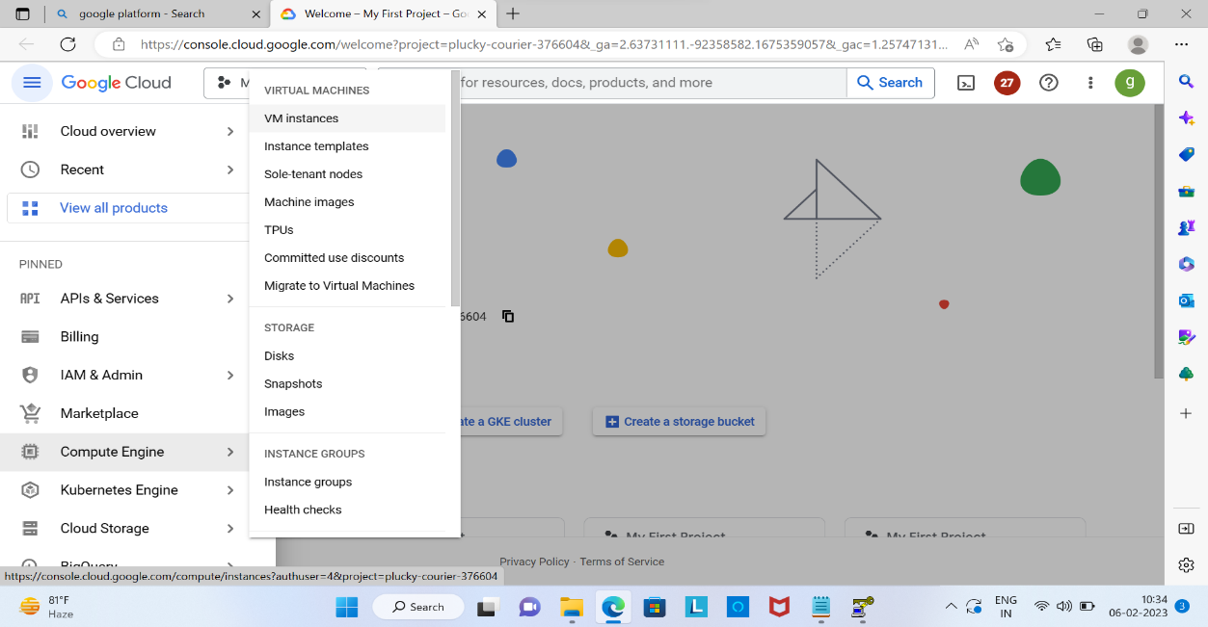



1. Give the meaningful Name to that instance. Select the desired region and instance type.

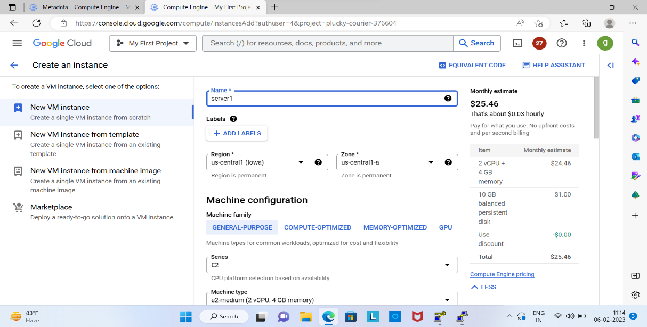

1. In Boot Disk go to **Change** option to choose a OS(image).

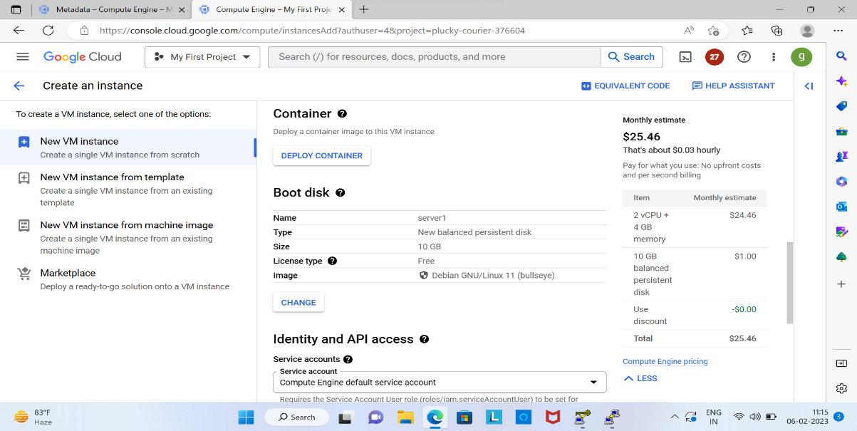



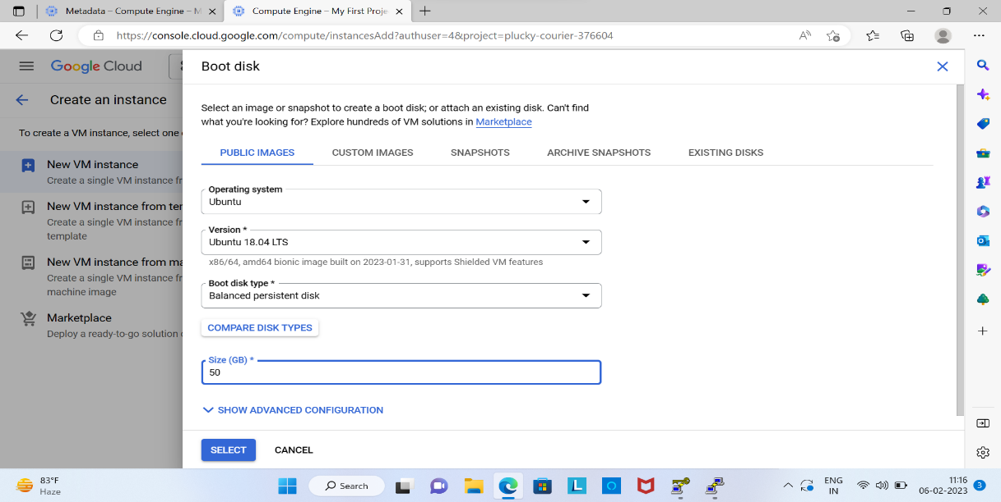

1. Setup the firewall rules to allow the incoming traffic as shown below. Then click on Create now instance will be create.

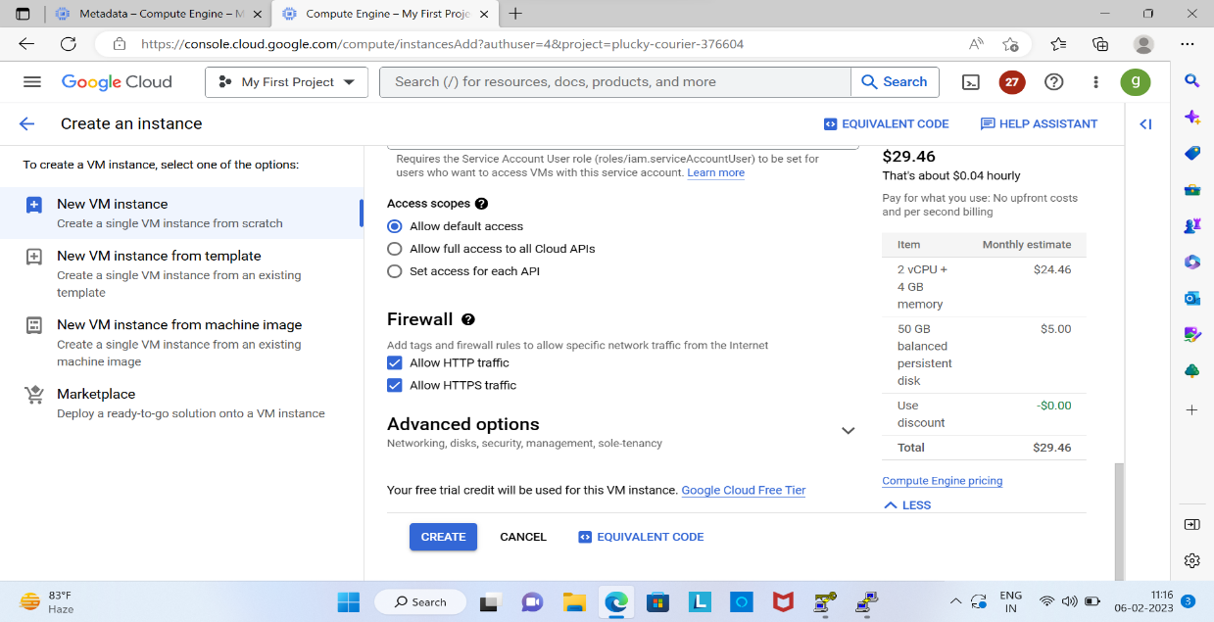

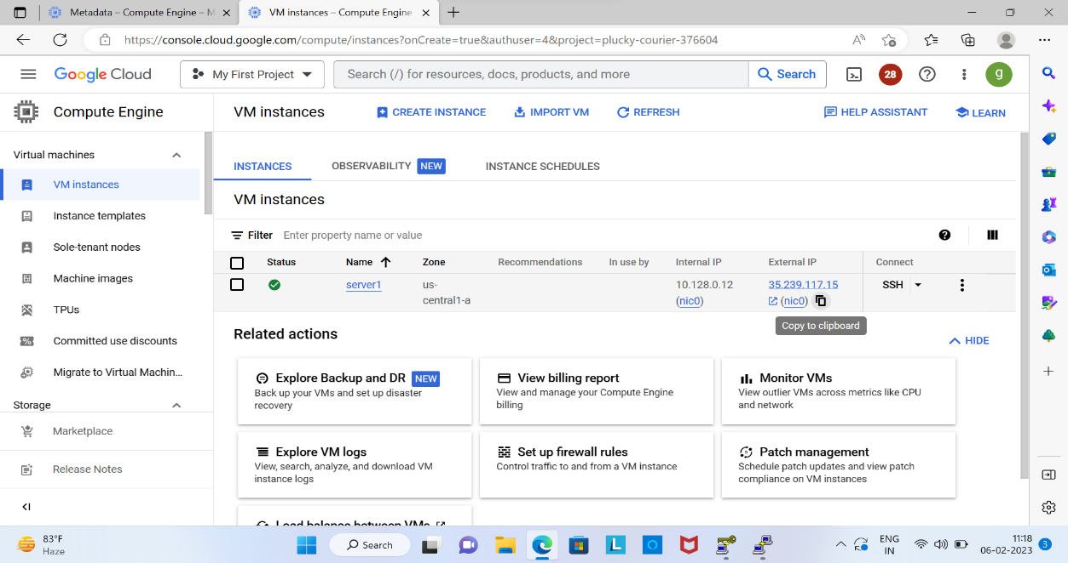

**To connect to an instance using Puttygen:**

1. Download and install Puttygen on your local machine. Launch puttygen and select the RSA option under the type of key to generate. Click the generate button to create a public/private key pair.

* Write the **key comment** name.

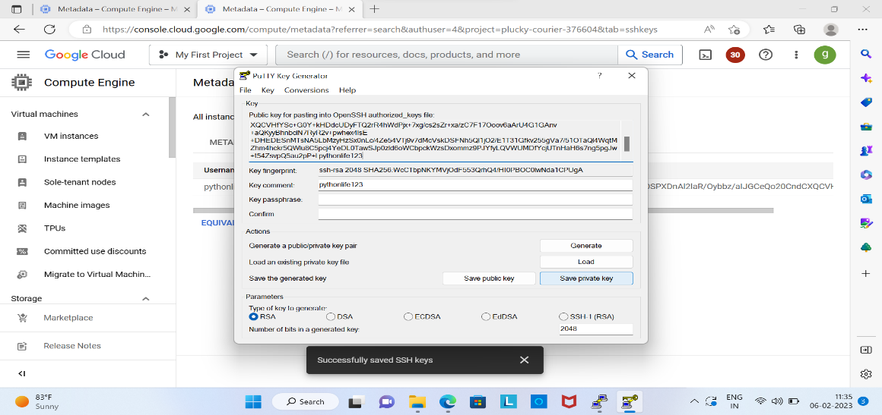

1. Copy the public key and add it to your instance’s authorized keys. So go to metadata using search option and save it.

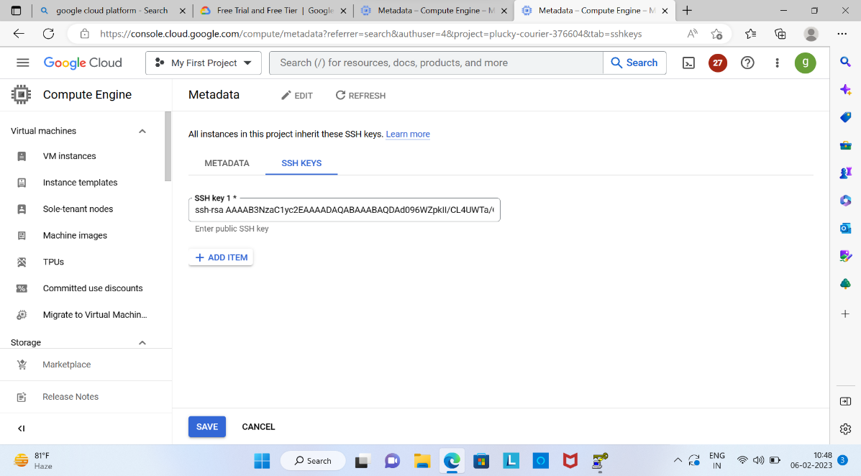



1. Save the private key to safe location.

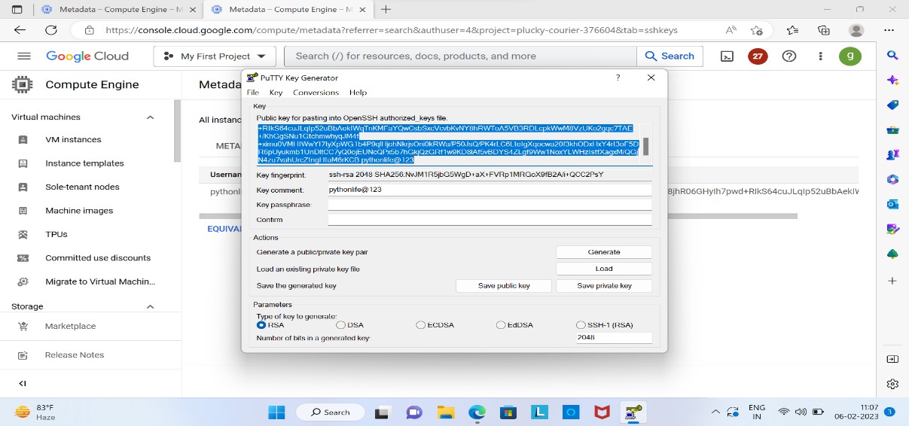



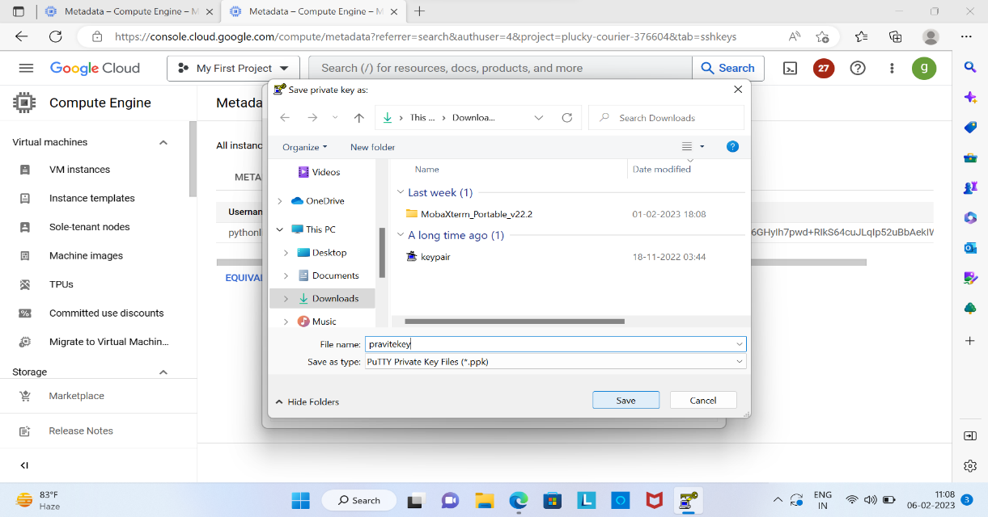

1. Start putty and enter the public IP address or hostname of your instance in the Host Name field.

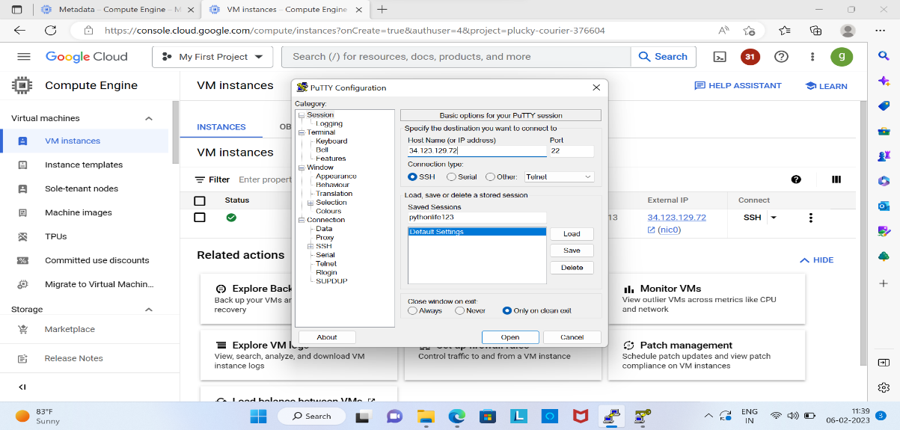



1. Click on **Data** give auto login username. Next Go to Connections>SSH>**Auth** section and select the private key which you generated with puttygen as shown below.

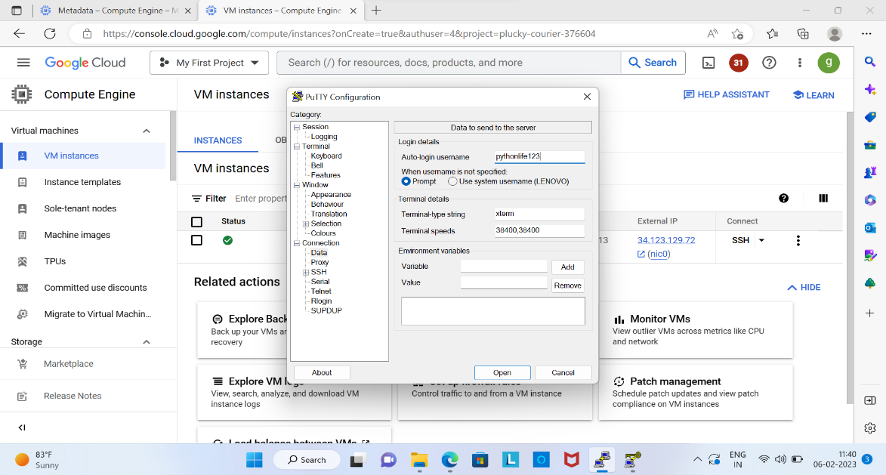



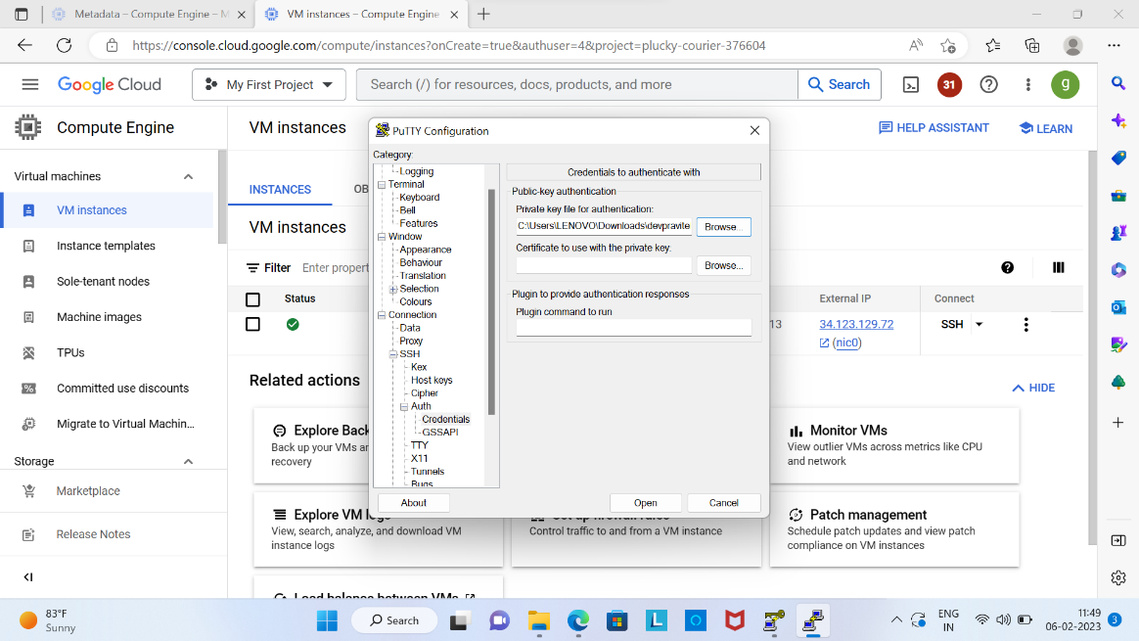



1. Next go to **session** click on Save option.

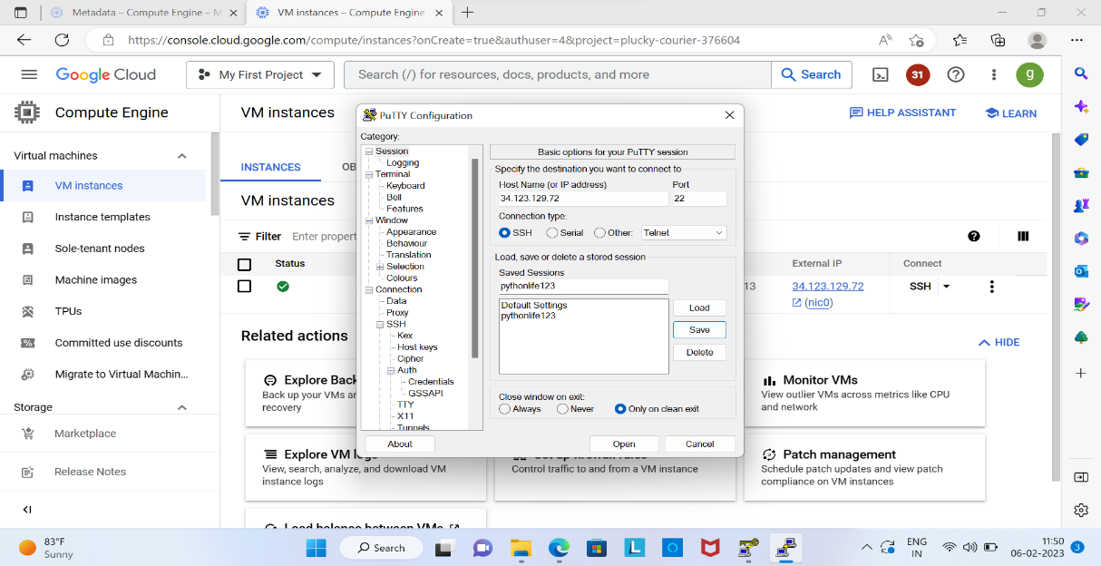



1. When we click on next, it will open as shown below.

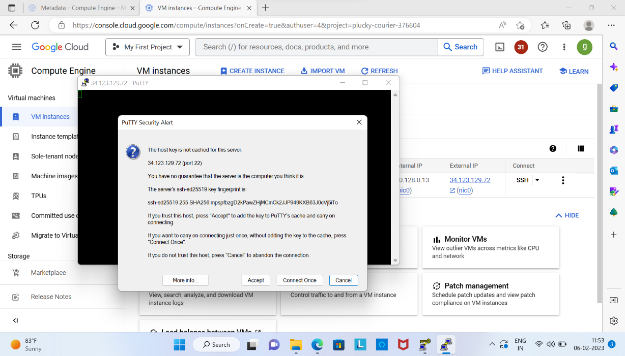



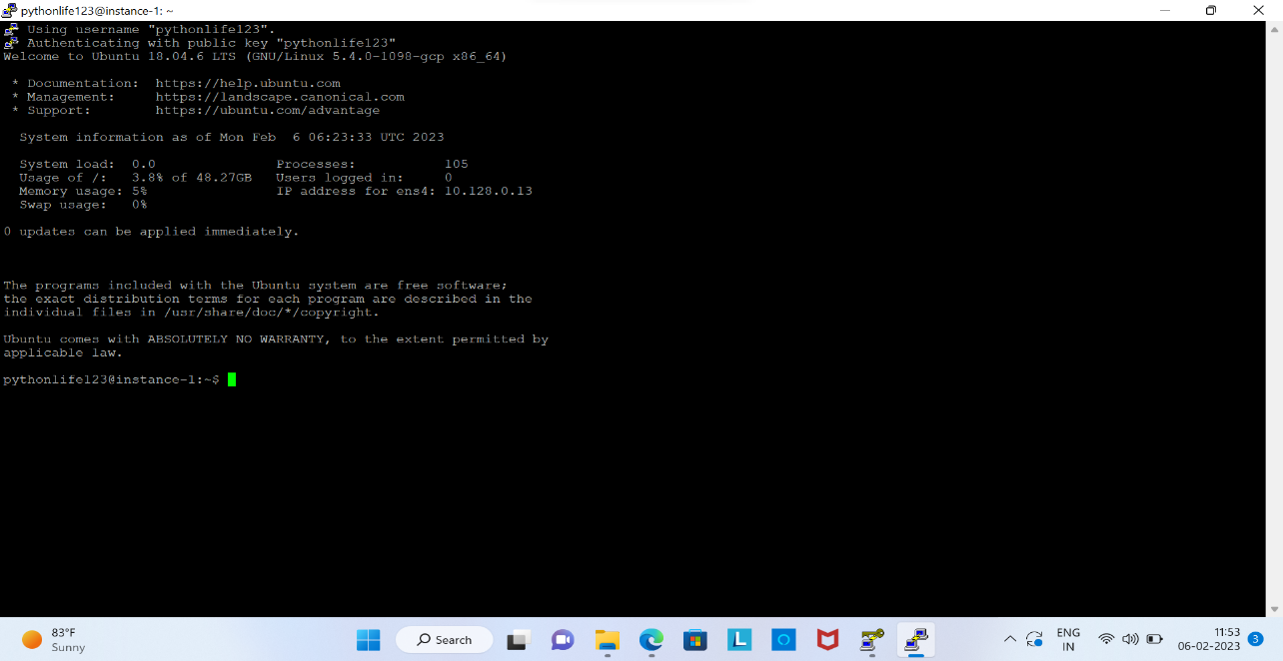

When we give sudo -i command. Sudo command **allows users to execute the programs with the privileges of other users, especially the default root user.**

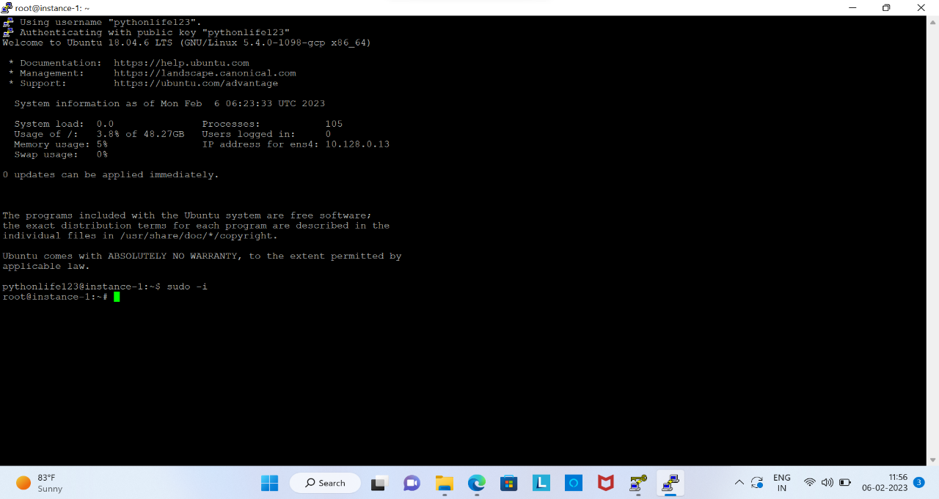

**Steps to access ports by creating firewall:**

1. Log in to GCP Console and navigate to the Networking section.
2. Click on the firewall rules option.

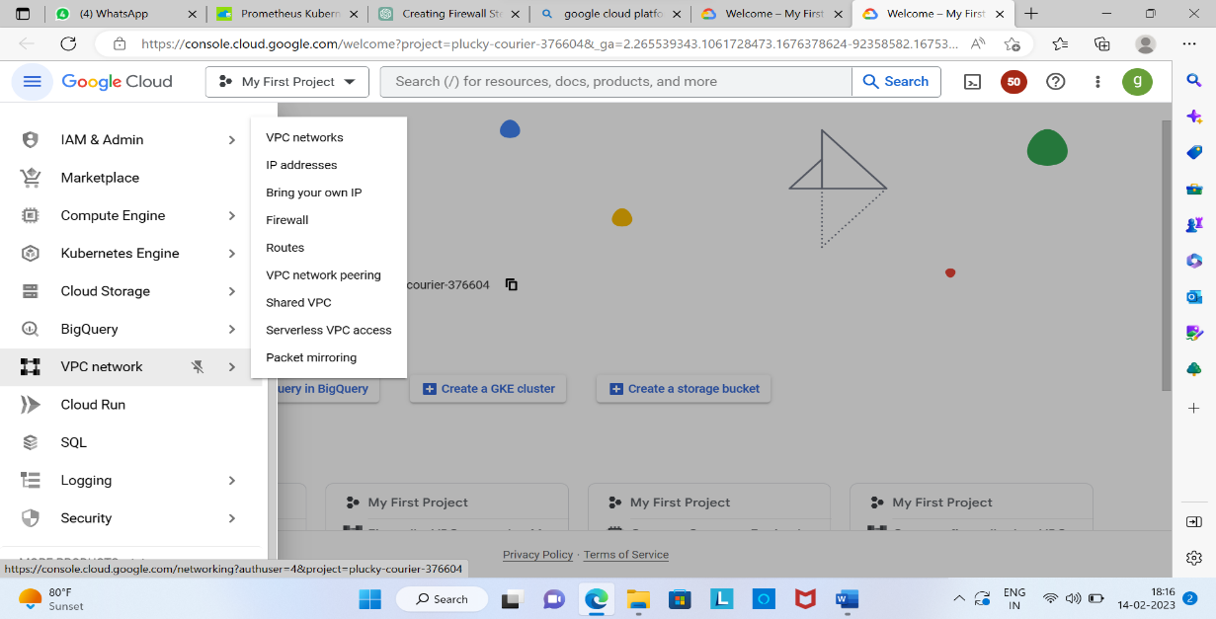



1. Click on the Create Firewall Rule button to open the creation form.

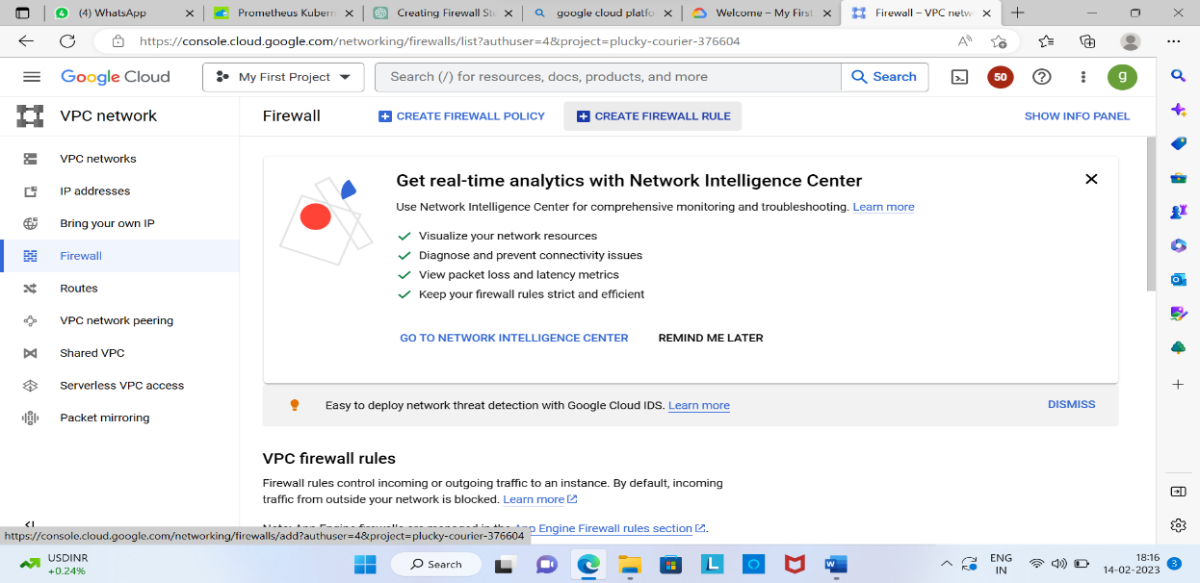



1. Fill the the form by specifying the name and description of the firewall rule, the direction of traffic (ingress or egress),and the priority of the rule.

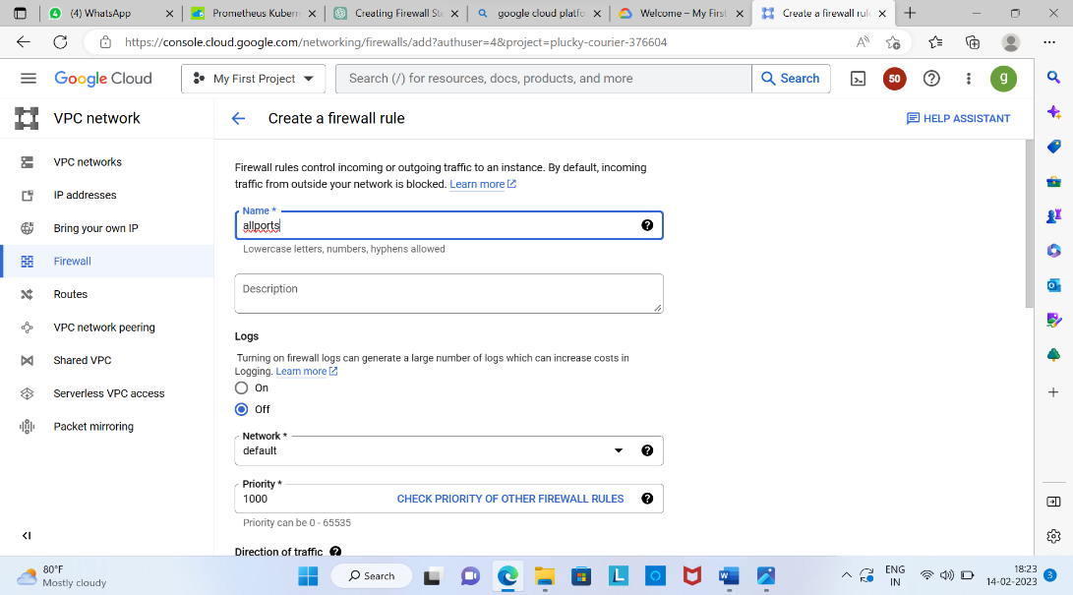

1. Specify the protocol and ports that you want to allow access to, using the port numbers or service names.

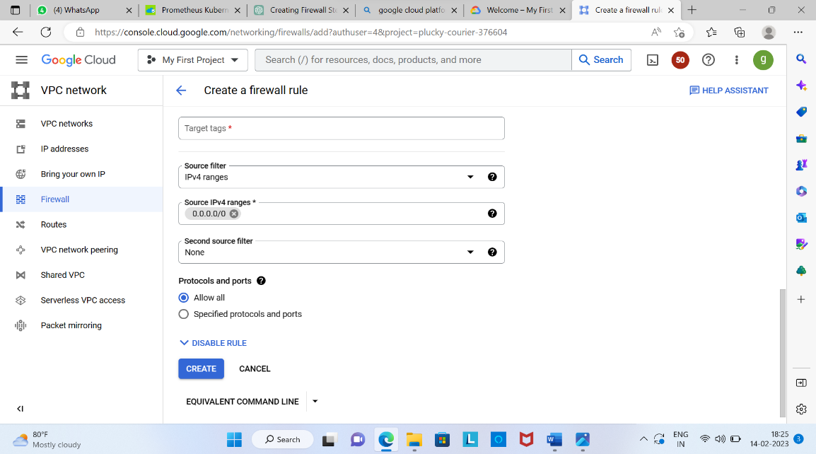



1. Click on the create button to create the firewall rule.
2. Test the firewall by accessing the port(s) from the allowed sources and verify the traffic is allowed while blocking other unauthorized traffic.